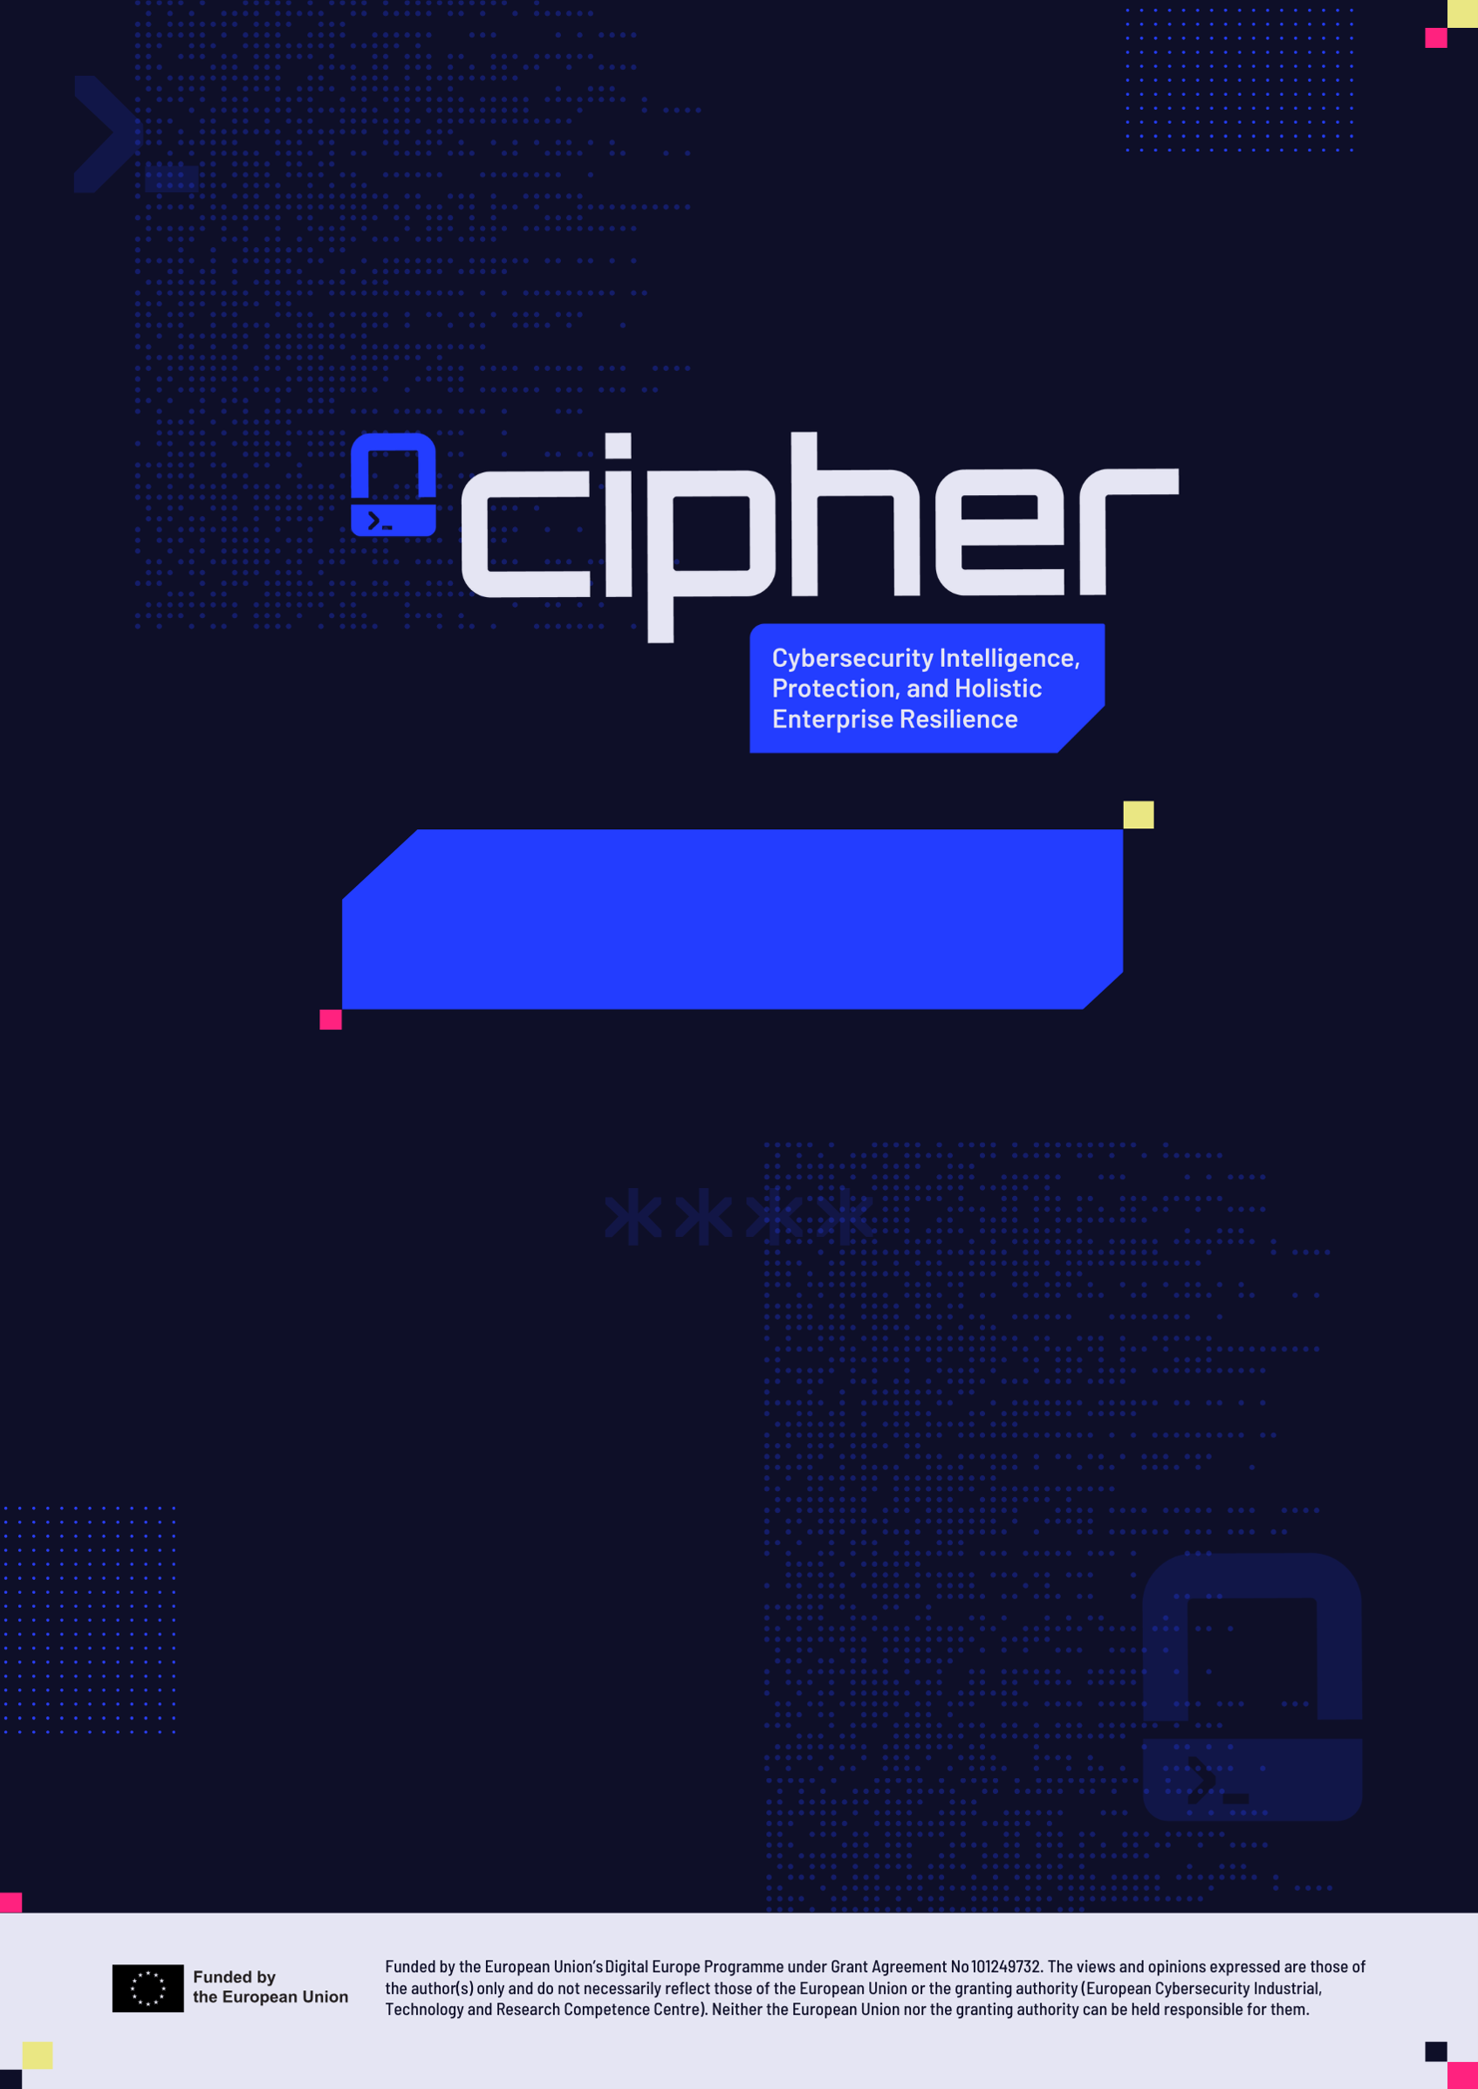
Annex 4 - Ownership Control Declaration
Nov 2026

Disclaimer
The views and opinions expressed are those of the author(s) only and do not necessarily reflect those of the European Union or the granting authority (European Cybersecurity Industrial, Technology and Research Competence Centre). Neither the European Union nor the granting authority can be held responsible for them.

Copyright Notice
© CIPHER
Funded by the European Union’s Digital Europe Programme under Grant Agreement No 101249732.

OWNERSHIP CONTROL DECLARATION
The information should reflect the situation at the moment you sign this declaration. Please be aware that additional information or clarifications may also be requested later on, in case there are open questions about your ownership/control status.
Please note that the information in this declaration may be reused in case you apply to other EU calls that have ownership/control restrictions.
Please also note that you must inform the granting authority in case of changes in your ownership and control structure during the project implementation, if these could impact the ownership/control requirements.)
DECLARATION ON OWNERSHIP AND CONTROL
Project
Name of the project: |  |  | [Cybersecurity Intelligence, Protection, and Holistic Enterprise Resilience] — [CIPHER]
Participant
Legal name:
PIC:
Legal registration number:
Place of establishment:
(country of registration; full address)
Headquarters
Location of global headquarters/head office:
(full address)
Location of the executive management structure: (if different from the location of global headquarters/head office; full address)
‘Executive management structure’ means a body appointed in accordance with national law, and, where applicable, reporting to the chief executive officer, which is empowered to establish the strategy, objectives and overall direction, and who oversees and monitors management decision-making.
Listed, subsidiary or controlled
Supporting documents (to be provided on request): report/minutes of the last three shareholders meetings, for each of the listed companies.
Are you listed on a stock exchange? |  |  | Yes/No
Are you a subsidiary of a listed company? |  |  | Yes/No
Are you controlled by a listed company? |  |  | Yes/No
If the reply is YES to any of these three questions, please provide:
Which stock exchange?
Legal name of the listed company:
Share of the float in the total outstanding shares:
‘Floating stock’ is the result of subtracting closely-held shares from the total number of issued shares. It represents the portion available for unrestricted trade on a regulated stock market.
Ownership structure and specific rights
In the table below, detail any owners that:
- detain, directly or indirectly, at least 5% in the capital or at least 5% of the voting rights, including through any content, understanding, relationship^{[1]} or/and intermediary
- have one or more of the following specific rights in relation to their ownership:
  - right to veto a transfer of shares
  - pre-emption rights
  - right to purchase additional shares or investment subject to conditions
  - right to sell shares (only for owners that are not established in eligible countries (i.e. legal entity) or do not have the nationality of one of the eligible countries (i.e. individual) and holding more than 5% of the voting rights).
Supporting documents (to be provided on request):
- commercial registry extracts, shareholders book or a declaration signed by the legal representative of the organisation and any other relevant document containing clear mention of the shareholders and their percentage of interest/voting rights
- shareholders’ agreement, memorandum of understanding among shareholders, statutes, articles of association or other relevant documents regarding the decision-making procedures within the legal entity, investment agreements between the shareholders, etc
- If there are legal persons as shareholders ^{[2]}, please provide also a graph describing the different ownership layers/chain of control until the ultimate owners.
The supporting documents must show the complete ownership structure, for the entity and all its layers of ownership, up to the ultimate owners and should reflect the situation at the moment you sign this declaration.

[1] This includes voting agreements between shareholders that would together have more than 5% of the voting rights or 5% of the capital.
[2] Detaining at least 5% in the capital or at least 5% of the voting rights.
Owner name |  | Country of establishment/ or nationality | How is the ownership/control held |  | Specific rights attached to shares
 |  | Country of establishment/ or nationality | by share [%] | by voting right [%] | Specific rights attached to shares
Corporate governance
Describe briefly:
- the decision-making bodies, their composition as well as their nationality or place of establishment (where applicable)
- the rules regarding election, appointment, nomination or tenure of members of the decision-making bodies or other management positions
- the decision-making procedures, including information regarding the required majority and/or quorum needed for decisions.
Supporting documents (to be provided on request): documents establishing/describing the decision-making bodies, rules regarding election, appointment, nomination or tenure, decision-making procedures within the legal entity (e.g. articles of association bylaws, reports on corporate governance, etc)
You can refer to specific sections of your supporting documents.
The same documents and information should be provided for each intermediate legal entity holding directly or indirectly 5% or more of the capital or voting rights, up to the ultimate owners of all the layers involved.
Insert text

Control
Commercial links conferring control
List individuals or legal entities with whom you (or your owners, including intermediate layers until the ultimate owners) have a commercial relationship that (1) leads to a similar level of control on management and resources as the ownership of shares or assets and (2) is of very long duration (e.g. very important long-term supply agreements or credits provided by suppliers/customers, coupled with structural links).
Supporting documents (to be provided on request): cooperation agreements with the customer or supplier, etc
Name |  | Country of establishment/ or nationality | Commercial link type  (Supplier, customer, etc…) |  | Indicative amount
Financial links conferring control
List individuals or legal entities (including controlling shareholders/owners) from whom you (or your owners) are financially dependent in a way that could allow them to obtain concessions in strategic business areas.
Supporting documents (to be provided on request): loan documents, by-laws, documents showing the link; etc
Name |  | Country of establishment/ or nationality | Financial link type |  | Indicative amount
Other sources of control
Indicate if there is any other mean, process or link ultimately conferring control to another country entity (similar level of control on management and resources as the ownership of shares or assets and of long duration).
Supporting documents (to be provided on request): documents showing the control
Insert text

 | - DECLARATION (EU-controlled)
We hereby confirm that:
- our organisation is EU-controlled
- the present declaration is true and sincere
- the information regarding ownership and control is accurate and reliable
- to the best of our knowledge, there are no other arrangements or coordination between shareholders from non-EU countries that would together exercise control
- to the best of our knowledge, there are no other financial or commercial links with non-EU countries/non-EU entities conferring control
- we are aware that false declarations may lead to proposal rejection/grant termination and to administrative sanctions under Articles 137 to 148 of the EU Financial Regulation 2024/2509.
 | DECLARATION (non-EU controlled)
We hereby confirm that:
- our organisation is subject to control by a non-EU country/non-EU entities/non-EU nationals
- the present declaration is true and sincere
- the information regarding ownership and control is accurate and reliable
- if needed, we will provide guarantees to prove compliance with the requirements set out in the call conditions.
Non-EU countries: |  |  | [insert names of non-EU countries]
Are all non-EU countries eligible for participation in the call? |  |  | Yes  No
 | DECLARATION (no change)
We hereby confirm that:
- there has been no change in our organisation’s ownership and control situation compared to the last ownership control declaration/assessment procedure by the EU services
- the present declaration is true and sincere
- if needed, we will provide guarantees to prove compliance with the requirements set out in the call conditions.
Last declaration/assessment: |  |  | [mm/YYYY (date of request of supporting documents by the EU services)]
Project name and acronym for which the last control assessment was done: |  |  | [project title] — [acronym]
Signature of the authorised person
Name and function: |  |  | [name NAME], [function]
Date of signature: |  |  | [date]
Signature and stamp: |  |  | [signature and stamp]

HISTORY OF CHANGES
VERSION | PUBLICATION DATE | CHANGE
1.0 | 15.07.2021 | Initial version (new MFF)
1.1 | 18.08.2021 | Exemption for entities validated as public bodies (instructions).
2.0 | 01.05.2022 | Template aligned with new guidance document. Extension of the obligation to associated partners for EDF. New declaration on no changes. New templates for guarantees and approvals.
3.0 | 01.10.2023 | Declaration for associated partners and subcontractors only if required by call conditions/call document.  Extension for ASAP.
4.0 | 01.09.2024 | Special condition for CEF-DIG in the guarantee template deleted.
5.0 | 01.01.2026 | Update to new Guidance on participation in EU calls with ownership and control restrictions.  Separation of declaration and guarantee template.  Update to the new Financial Regulation 2024/2509.

